Summary

Introduction

Edge-preserving filters exploit spatial information to avoid the filtering near edges, while effectively smoothing other regions withinan image. Such edge-preservation filters have proven useful in a wide range of applications despite having widely differentformulations. For instance, some tasks, such as tone-mapping,may use these filters to decompose images intomultiple scales for processing

Previous work

Image filters are techniques which operate on all pixels of an image or only within a specific vicinity which are global or local.

Global filters are those filters that utilise information from all pixels in the input image to create a filtered image. Often, these filters are formulatedusing an optimisation problem that places constraints on therelationship between neighbouring pixels. The problem can be viewed as a Markov random field (MRF) using graph cutting techniques. Global filters are capable of producing high-quality filtering output. Unlike local filters, they tend tobe more resilient to artefacts even when aggressively filteringan image.

Localfiltering means that each operation can be treated indepenently, which lends towards a divide-and-conquer approach. This makes processing more readily mappable into hardware. Local filters tend to operate with smaller problem sizes as compared to theirglobal counterparts. The guided filter achieves filtering using a local lineartransform of a guide image. By exploiting structure remapping,the design of the guided filter avoids gradient reversal artefacts. The domaintransform [42] is partly an approximation of the bilateralfilter designed with lower complexity.

The guided filter takes the idea shape transformations on an image locality to perform filtering. In vector space, the operation of the guided filter can be bedivided into two parts. The resulting transformation for the patch:describes a resultant vector with a fixed magnitude along the vector and a variable magnitude along its orthogonal counterpart. The guided filter behaves isotropically on a patch level. It diffuses all structural information equally within the same patch, without any regard to spatial distance. In this diffusive perspective, the factor ai effectivelyrelates to the degree of diffusion in the resulting patch.

The filter is region-selective and can be said to be anisotropic, but only weakly so. A notable observation from the filtered signal is that the filtering strength appears to be weaker near the edges, which makes the appearance of noise more prominent in these regions. The effect of averaging enforces a low-pass filter which destroys any aggressive  anisotropic capabilities of the filter.

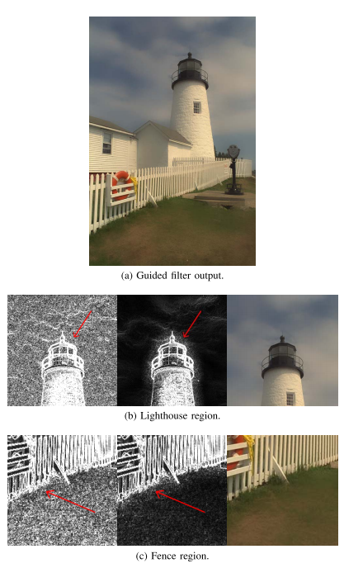

The Anisotropic Guided Filter (AnisGF) is a modified version of the original guided filter. Unlike its predecessor, the AnisGF operates with O(n)complexity and is solely dependent on the number of pixels. It is slightly more expensive to implement than the original filter due to the addition of calculations.

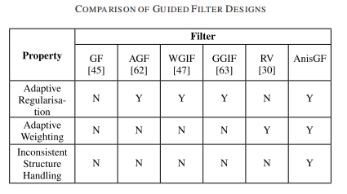

Comparisons

The AnisGF is a derivative of the guided filter and shares many of the characteristics of the original guided filter. It is formulated explicitly to handle full adaptation and, at the same time, strongly adhereto the gradient structure of the guide image. This allows it to behave more closely to global filtering methods that function based on a gradient penalty.

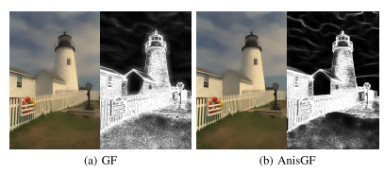

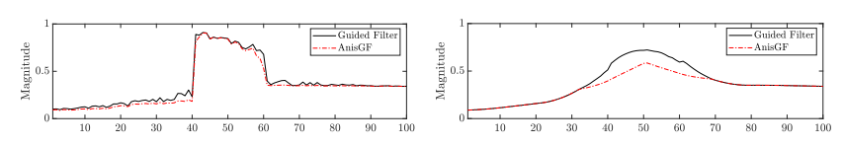

Experiments

The Anisotropic Global Filter (AnisGF) has been developed to address the limitations of the guided filter. The AnisGF avoids the appearance of detail halos and other artefacts caused by large windowsizes. It also ensures that the image is uniformly smoothed even while approaching detailboundaries. Images obtained from the different filters can be seen. While not immediately apparent, the guided filtershows some level of scale-awareness as the smaller boxesbecome more prominently blurred. However, the detail haloing phenomenon counteracts this effect, thus leading to poor scale-aware filtering results.

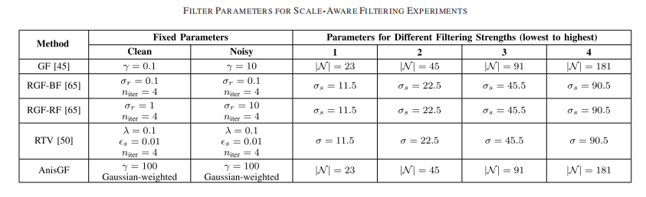

The process of texture removal is closely related to the properties of a filter and involves the elimination of features below a given scale, while ensuring sharp edges. The conditions of tex-ture removal are largely incompatible with the behaviour of a scale-aware filter, thus leading to poor performance. The fast weighted-ivalent1 (FWL1) filter has difficulty dealing with the large intensity variations from the texture. The anisotropic behaviour of the AnisGF, combined with the locally isotropic properties of the guided filter, can effectively handle texture removal.

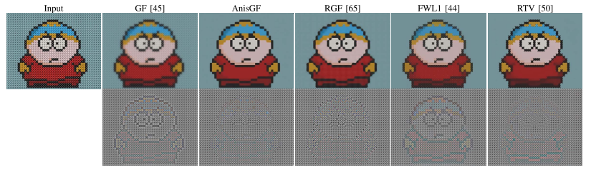

The AnisGF is a more elaborate formulation than the. original guided filter but still operates with low.computational complexity, as noted earlier in the discussion.

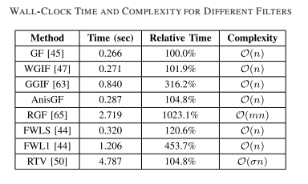

This work measures the wall-clock time of the Anis GF in comparison to the original guidedfilter. The AnisGF can be seen as a generalised guided filterwhich can be parametrised to exactly replicate the behaviourof the latter. This characteristic implies that the new filter maybe used in the many applications that already benefit from the performance of the guided filter while bringing anisotropy asan added capability.